Business Plan


Nioor

Ecommerce Business

Online Store for Asian Women

Idea

Why? (Problem)
Noor is a brand which runs the online retail store Nioor.com. The primary product line focuses on women's clothing, targeting the Asian community, specifically Bangladeshi, Indian and Pakistani female consumers. Nioor aims to bridge the gap between customers and vendors, acting as a tech company providing vendors with a selling solution. This includes product photography, inventory management, shipping management, till services and payment solutions. What sets us apart is that we will be the only online retail solution focused on Asian women, with multiple vendors available through a mobile app.

While some companies sell their products through Facebook and have proper websites, we will be a marketplace for the same products, creating opportunities for existing vendors.

What? (Solution)

Running an online multi-vendor platform website and mobile app targeting Asian women's clothing, accessories, and beauty line presents several compelling reasons to enter this market segment.

Firstly, the market is growing rapidly. According to a report by ResearchAndMarkets, the Asian women's clothing market is expected to grow at a CAGR of 9.4% from 2021 to 2028. The same report also highlights the growing demand for beauty products in the Asia-Pacific region, which is expected to reach USD 256 billion by 2026.

Secondly, operating an online multi-vendor platform involves relatively low overhead costs compared to a traditional brick-and-mortar store. This can help keep operational costs low while still reaching a vast audience. According to a report by BigCommerce, the average cost of starting an online business is significantly less than starting a brick-and-mortar store.

Thirdly, having multiple vendors can offer a wide range of products and styles, catering to different tastes and preferences. This can help attract and retain customers. A report by Accenture highlights that 63% of customers prefer to shop with retailers that offer a wide range of products.

Fourthly, the convenience of shopping online is becoming increasingly popular. According to a report by Statista, e-commerce sales in the UK are projected to reach £114 billion by 2024, indicating the growing demand for online shopping. Operating an online multi-vendor platform provides customers with the convenience of shopping from the comfort of their own home or on-the-go through the mobile app.

Finally, an online multi-vendor platform is highly scalable, allowing you to add new vendors and products as the business grows. This can help keep up with the increasing demand and ensure that the business remains relevant and competitive.

Overall, the statistics and research show that operating an online multi-vendor platform website and mobile app targeting Asian women's clothing, accessories, and beauty line presents a viable and growing market opportunity with relatively low overhead costs, offering customers convenience and variety.

Product
Nioor is a technology company that aims to bridge the gap between vendors and customers by providing them with a platform. Our revenue stream comprises of five different paths, namely sales commission, product shoots, advertising, customer subscriptions, and vendor subscriptions.

Unique Selling Proposition
- Nioor offers a unique platform that connects vendors and customers in a seamless way.
- Advertising options allow vendors to target their ideal audience and increase their visibility.
- It will improve productivity and efficiency

 |  |  | 
Sales Commision | Product Shoot | Advertisement | Customer Subscription
Nioor will charge commission from every product sales in our platform. | Nioor offers professional product photography services to help vendors showcase their products in the best light possible. | Vendors Can promote their product to boots them up | Our customer subscription service provides a convenient way for customers to purchase products and receive regular updates and exclusive offers.
Key Differentiators  Vendors sales increase, commission rate decreases | Key Differentiators  Only nioor provide this service | Key Differentiators  Very specific targeted audicenc for promotion | Key Differentiators  Free Delivery and get gift every month


Vendors Subscription
Vendors will get compile services such as product shoot or reduce commission fee on subscription
Key Differentiators
Reduce or avoid sharing commision

More Details

Promotion
Here are some potential unique ways to promote Nioor:
- Influencer Marketing: Partner with social media influencers in relevant niches to showcase the benefits of using Nioor to their followers. This can help generate buzz and reach a wider audience.
- Referral Program: Offer a referral program for existing vendors and customers to invite their friends and colleagues to use Nioor. This can incentivize word-of-mouth marketing and help grow your user base.
- Local Partnerships: Form partnerships with local businesses and organizations to promote Nioor to their networks. This can help establish Nioor as a trusted platform in the community.
- Events: Hosting fashion shows could be an effective way for Nioor to promote its platform, particularly if the focus is on showcasing the products of the vendors who use Nioor's services.
- User-Generated Content: Encourage users to share their experiences using Nioor on social media, and feature the best posts on the Nioor website and social media channels. This can help build social proof and encourage more people to try Nioor.
- Guerrilla Marketing: Use creative and unconventional tactics, such as chalk art or street performances, to grab people's attention and promote Nioor. This can help generate buzz and increase brand awareness.

 |  |  | 
Public relations | Search Engine Optimization | Pay Per Click Advertising | Email Marketing
We will contact women's magazines, beauty and life sections of newspapers, and television stations and send them a press release describing our unique value proposition. | We will create a website in such a manner as to direct as much traffic from search engines as possible. The original website designer will use knowledge of search engine optimization to orient the website’s content towards this end and begin a program of link exchange to move up the search engine rankings. | We will use highly-focused, specific keywords to draw traffic to its website through text pay-per-click advertising on Google. Advertisements will be targeted at potential clients who will find our content-rich site to be a valid resource and applicable to their interests. | We will publish a monthly email newsletter to tell customers about trends in skincare. Email addresses will be gathered from users who opt-in when using the website. The email newsletters will support the brand of the site as an expert in skincare. In addition, emails presenting new offers or products will be sent once a week to keep the customers informed of the latest information on the website.

 |  |  | 
Events | Word of mouth | Instagram | Facebook
Attend all possible Asian events to make sure we are reaching the right audience. | Word of mouth that is going to be our main eﬀort from day. To emphasise we will use influence to promote nioor. | Nioor will use Instagram promotion to increase brand awareness and drive sales. By creating visual content, targeting the right audience and using Instagram Stories and influencers, Nioor can attract new customers and grow revenue. | Nioor can use Facebook promotion to increase brand awareness and drive sales. By creating engaging content, targeting the right audience, and using Facebook Ads and retargeting, Nioor can grow its customer base and increase revenue.

Distribution
- Nioor is accessible via both its website and mobile application. Our products will be distributed by reputable shipping partners, including DHL, Hermes, DPD, Royal Mail, Evri, Parcelforce Worldwide, Yodel, UPS, TNT, FedEx, DX Delivery, UK Mail. By partnering with a variety of reputable shipping companies, Nioor can ensure that its products are delivered quickly and reliably to customers throughout the UK.

- Customers have the option to select their preferred shipping company after receiving a shipping quote. This allows customers to choose the most affordable and suitable shipping option for their needs.

 | 
Website | Mobile App | Shipping
With a diverse range of products available, Nioor can attract customers with varying tastes and preferences. Nioor provides a selling solution to vendors, including product shoot, inventory management, shipping management, and payment solution, reducing the gap between the customer and vendor. By offering a one-stop-shop for vendors to sell their products, Nioor is creating new opportune | Nioor is integrated with all major shipping companies in the UK. This allows customers to easily compare and select their preferred and most affordable shipping method.

Partners
Nioor is a multi-vendor platform that offers an extensive range of women's products, including Kameez, Lehenga, Saree, Hijab and Accessories, sourced from various vendors. Nioor intends to procure all the major local brands in the UK for these categories, ensuring a diverse and comprehensive selection for our customers.



Multi Vendors | Beauty Product
Nioor is a multi-vendor platform that offers a wide range of products, including Kameez, Lehenga, Saree, Hijab and Accessories, for women from a variety of vendors. | Nioor will collaborate with major beauty brands such as MAC, L'Oreal, Maybelline, and Revlon. By partnering with these major brands, Nioor can offer a diverse range of beauty products. This collaboration will not only provide customers with access to top beauty brands but also offer a convenient shopping experience by having all products available on one platform.

Market
According to a report by Research and Markets, the UK Asian women's clothing and accessories market was valued at £5.6 billion in 2020 and is expected to grow at a CAGR of 7.2% from 2021 to 2028. The report attributes this growth to factors such as increasing disposable income, growing fashion consciousness, and the popularity of social media influencers.

In terms of beauty products, a report by Mintel estimates that the UK South Asian beauty market was worth £267 million in 2019 and is projected to reach £361 million by 2024. The report highlights that the demand for natural and organic beauty products is on the rise, as well as the need for products that cater to a diverse range of skin tones.

These figures suggest that the Asian women's clothing, accessories, and beauty product market in the UK is a significant and growing industry with ample opportunities for growth and development.

Market Coverage



National market
You distribute your products and services across the country</br></br>

Market Growth



Growing
There is an overall increase in demand for the products and services you plan to sell

Customers
According to Invesp, 79% of females and 77% of males who have internet access have purchased something online in the past 12 months.

Those aged 50 to 64 are the most likely to make an online purchase, followed closely by those aged 30 to 49.

 |  | 
Ladies 18-30 years | Ladies 30-45 years | Ladies 45-55 years
Consumers in this segment have the least discretionary income to spend on e-commerce. | Consumers in this segment have significant exposure to the internet and can afford higher-priced goods. They are driven to e-commerce and online auctions by convenience. | Consumers aged 45 to 55 generally have higher disposable income for industrial goods. This segment is often more concerned with convenience than the price of online items.
Pain points  Learning about new brands  Multiple brands in one place  Enjoyable eCommerce experience | Pain points  Customer support in choosing the right product  Learning about new products on the market  Promotions for various skincare items in one place | Pain points  Convenient shopping experience  Finding multiple products and brands in one place
Market Size 4/5  Pay for value 3/5  Accessibility 5/5  Priority High | Market Size 4/5  Pay for value 4/5  Accessibility 5/5  Priority High | Market Size 2/5  Pay for value 4/5  Accessibility 3/5  Priority Medium

More Details

Competitors
(T)

We have several advantages over its competitors. These advantages include:

- Niche Market Focus: By serving the niche market of eco-conscious products, Vivid will be able to focus its products on the needs of these customers more so than larger, entrenched competitors.
- Founder knows many of the best programmers and web development companies. With such relationships, it will be relatively easy for us to build the website’s functionality.
- Community: By developing a community of ladies that really care about what they apply to the skin and with online shoppers, Vivid will strengthen its brand loyalty



Asiancouture.co.uk | Diyaonline.com | andaazfashion.co.uk | uk.khaadi.com
At Asian Couture, Th Sell Asian Clothes Man and Women categories. They Started their journey in 2021.  Not a Marketplace  No App | Diya Online is your one stop solution for every ethnic and festive need.  Not a Marketplace  No App | an online store that offers a range of ethnic wear for women, including Indian, Pakistani, and Bangladeshi clothing.  Not a Marketplace  No App | a clothing brand that offers a range of Pakistani clothing for men, women, and children.  Not a Marketplace  No App
Price Fair  Quality Good  Customer Service Fair  Reputation Fair  Location Good | Price Good  Quality Good  Customer Service Good  Reputation Good  Location Good | Price Good  Quality Excellent  Customer Service Excellent  Reputation Excellent  Location Good | Price Good  Quality Excellent  Customer Service Excellent  Reputation Excellent  Location Excellent
Threat Level  Medium | Threat Level  Medium | Threat Level  High | Threat Level  High

SWOT Analysis

Strengths
There are several strengths associated with a multi-vendor online platform like Nioor. Some of these strengths include:

- Wide product selection: A multi-vendor platform allows for a diverse range of products to be offered to customers, which can increase customer satisfaction and loyalty.
- Competitive pricing: The presence of multiple vendors can lead to price competition, which can result in lower prices for customers and increased sales for vendors.
- Increased customer reach: With multiple vendors selling on the platform, Nioor can reach a larger audience, increasing the potential customer base and revenue.
- Lower operational costs: As vendors are responsible for shipping and fulfillment, Nioor may have lower operational costs compared to traditional e-commerce models.
- Brand recognition: By partnering with multiple vendors, Nioor can increase brand recognition and establish itself as a trusted online marketplace.
- Flexibility: A multi-vendor platform allows for flexibility in terms of the number of vendors that can be added, the range of products offered, and the ability to adapt to changing market trends.

Overall, a multi-vendor online platform like Nioor can offer many strengths that can benefit both vendors and customers.

Weaknesses
There are several potential weaknesses that could be associated with a multi-vendor online platform like Nioor. Some of these weaknesses include:

- Trust issues: As the platform allows multiple vendors to sell their products, customers may find it difficult to trust the vendors, especially if they are not well-known brands.
- Quality control: The platform may not have control over the quality of products being sold by the vendors, which could lead to inconsistent product quality and a negative customer experience.
- Competition among vendors: The presence of multiple vendors may lead to intense competition among them, resulting in pricing wars and other issues that could negatively impact the platform.
- Technology challenges: Maintaining a complex online platform that accommodates multiple vendors and their products can be challenging from a technology perspective, including managing data, ensuring security, and preventing fraud.
- Customer service issues: If a customer has a problem with a product from one of the vendors, it can be challenging to determine who is responsible for resolving the issue, and the customer service experience may suffer as a result.

Overall, a multi-vendor online platform like Nioor can offer many benefits, but it is important to be aware of the potential weaknesses and take steps to mitigate them.

Opportunities
There are several opportunities associated with a multi-vendor online platform like Nioor. Some of these opportunities include:

- Increased sales and revenue: By offering a wide range of products from multiple vendors, Nioor can increase sales and revenue.
- Geographic expansion: As an online platform, Nioor has the potential to expand its reach beyond its current geographic location, allowing it to tap into new markets and increase its customer base.
- Partnerships with vendors: Nioor can partner with vendors to offer exclusive products or discounts, which can increase customer loyalty and sales.
- Improved customer experience: By offering a diverse range of products and a seamless shopping experience, Nioor can improve the customer experience, which can lead to increased customer loyalty and positive word-of-mouth marketing.
- Data analytics: As an online platform, Nioor can leverage data analytics to gain insights into customer behavior and preferences, which can help to optimize its product offerings and marketing strategies.
- Strategic acquisitions: Nioor has the opportunity to acquire other online marketplaces or complementary businesses to expand its offerings and customer base.

Overall, a multi-vendor online platform like Nioor has many opportunities to grow and expand, both through strategic partnerships, acquisitions, and leveraging technology to improve the customer experience.

Threats
There are several threats associated with a multi-vendor online platform like Nioor. Some of these threats include:

- Competition: There are many other multi-vendor online platforms out there, and Nioor may face stiff competition from established players in the market, which can lead to decreased market share and revenue.
- Vendor reliability: The platform may face issues with vendor reliability, including issues with product quality, fulfillment, and customer service, which can negatively impact the customer experience and damage Nioor's reputation.
- Cybersecurity threats: As an online platform, Nioor is vulnerable to cybersecurity threats such as data breaches, hacking, and other forms of cyber attacks that can compromise customer data and lead to reputational damage.
- Regulatory risks: Nioor may face regulatory risks associated with data privacy, taxes, and other regulations that can impact its operations and revenue.
- Economic uncertainty: Economic instability or downturns can negatively impact Nioor's revenue, as consumers may be less likely to spend on non-essential items.
- Technological disruptions: Rapid advancements in technology can disrupt the online marketplace and lead to new competitors and changes in consumer behavior.

Overall, a multi-vendor online platform like Nioor faces several threats that require careful management and mitigation to ensure its long-term success.

Market Potential

 | Market Potential  
  Total Addressable Market
  £891,000,000
  Serviceable Available Market
  £89,100,000
  Share of Market
  £2,673,000

Marketing Budget
This is the marketing budget that we need to promote our product and service

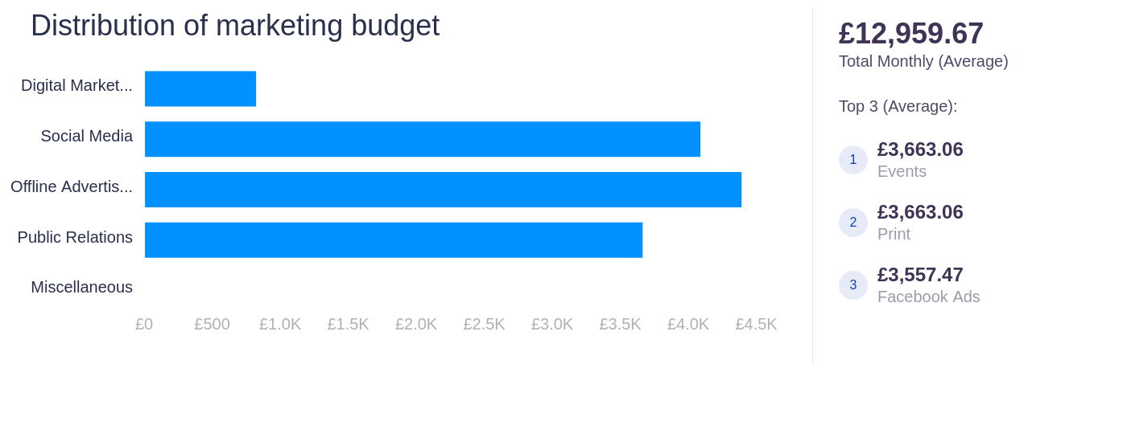

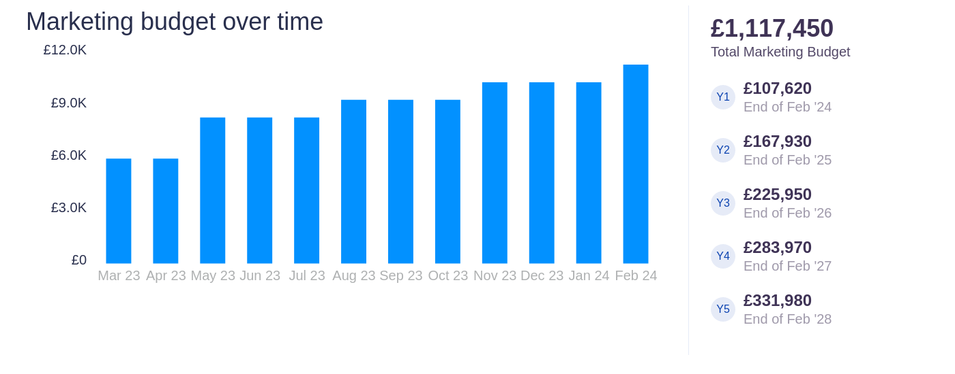

Marketing Budget (£) | Y1 | Y2 | Y3 | Y4 | Y5
Digital Marketing | 7,500 | 9,433.33 | 9,970.83 | 10,530.21 | 983.33
Email campaigns | 500 | 683.33 | 783.33 | 883.33 | 983.33
Pay per click | 5,000 | 6,250 | 6,562.50 | 6,890.63
SEO | 2,000 | 2,500 | 2,625 | 2,756.25
Social Media | 14,040 | 31,526.67 | 47,686.67 | 63,846.67 | 80,006.67
Facebook Ads | 9,000 | 25,333.33 | 41,333.33 | 57,333.33 | 73,333.33
Instagram Ads | 5,040 | 6,193.33 | 6,353.33 | 6,513.33 | 6,673.33
Offline Advertising | 42,000 | 47,400 | 52,140 | 57,354 | 63,089.40
TV | 6,000 | 7,800 | 8,580 | 9,438 | 10,381.80
Print | 36,000 | 39,600 | 43,560 | 47,916 | 52,707.60
Events | 36,000 | 39,600 | 43,560 | 47,916 | 52,707.60
Totals | 99,540 | 127,960 | 153,357.50 | 179,646.88 | 196,787

Other Overheads
And this is how much money we will spend on other overheads

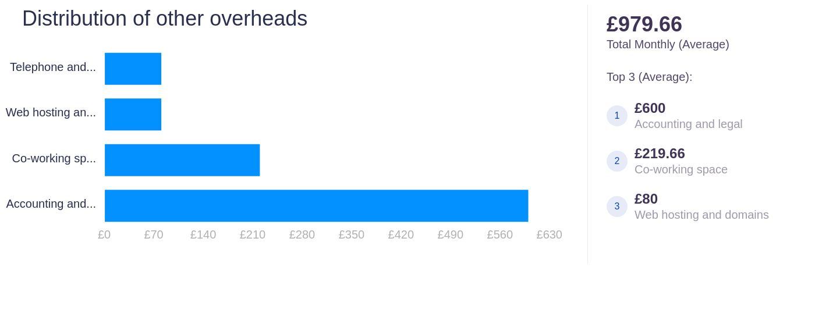

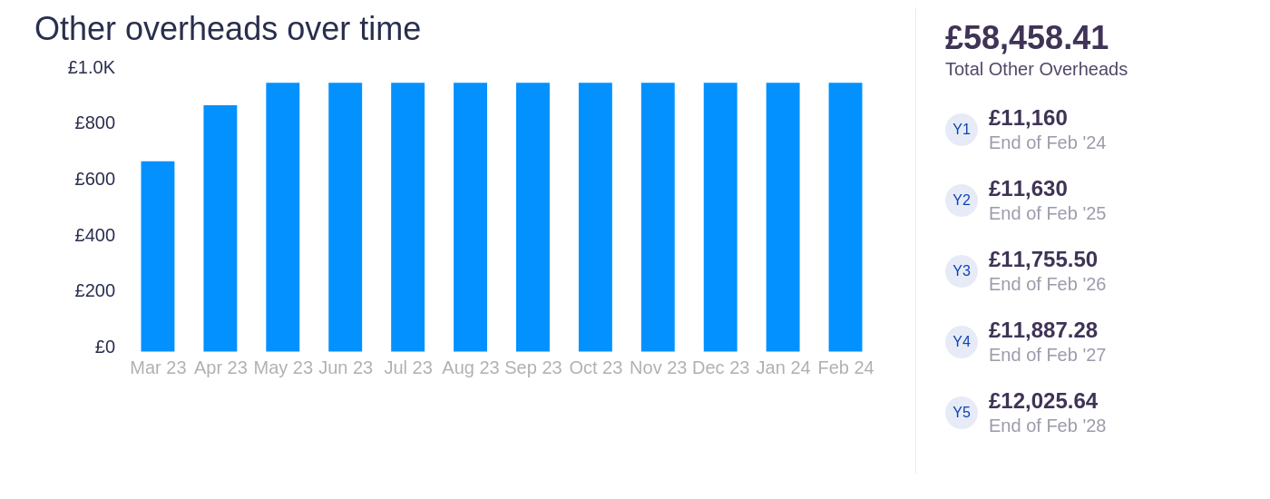

Other Overheads (£) | Y1 | Y2 | Y3 | Y4 | Y5
Accounting and legal | 7,200 | 7,200 | 7,200 | 7,200 | 7,200
Web hosting and domains | 960 | 960 | 960 | 960 | 960
Telephone and Internet | 800 | 960 | 960 | 960 | 960
Co-working space | 2,200 | 2,510 | 2,635.50 | 2,767.28 | 2,905.64
Totals | 11,160 | 11,630 | 11,755.50 | 11,887.28 | 12,025.64

Profit & Cash Flow

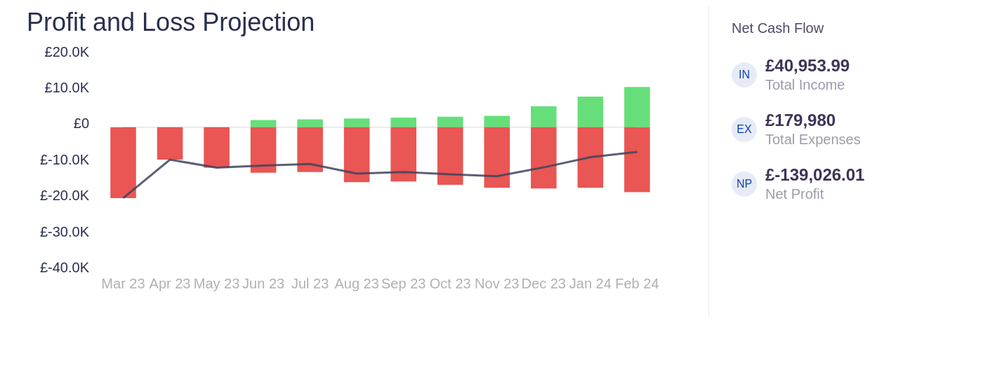

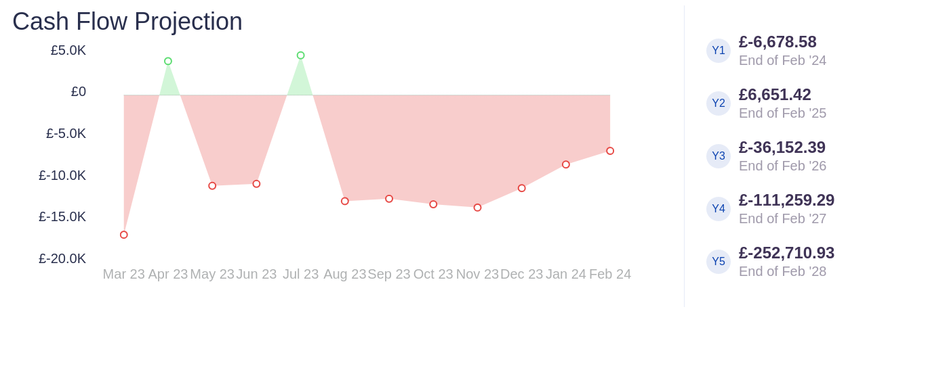

Income Expenses (£) | Y1 | Y2 | Y3 | Y4 | Y5
Total Revenue | 40,953.99 | 371,837.48 | 966,136.03 | 1,986,693.90 | 3,971,670.23
Direct Costs
Gross Profit | 40,953.99 | 371,837.48 | 966,136.03 | 1,986,693.90 | 3,971,670.23
Operating Expenses | 180,980 | 252,244 | 316,773.50 | 381,309.28 | 435,841.64
Operating Income | -139,026.01 | 120,898.48 | 650,788.03 | 1,606,936.90 | 3,537,514.23
Total Interest Expense
Accrued Income Taxes |  | 25,515.10 | 130,157.61 | 321,387.38 | 707,502.85
Total Expenses | 180,980 | 277,759.10 | 446,931.11 | 702,696.66 | 1,143,344.48
Net Profit | -139,026.01 | 95,383.38 | 520,630.42 | 1,285,549.52 | 2,830,011.38

Cash Flow (£) | Y1 | Y2 | Y3 | Y4 | Y5
Cash Flow - Operations | -137,175.01 | 102,230.96 | 534,214.72 | 1,310,642.32 | 2,881,488.81
Cash Flow - Financing | 30,000
Cash at the Beginning of Period |  | -107,175.01 | -4,944.06 | 529,270.67 | 1,839,912.99
Net Change in Cash | -107,175.01 | 102,230.96 | 534,214.72 | 1,310,642.32 | 2,881,488.81
Cash at the End of Period | -107,175.01 | -4,944.06 | 529,270.67 | 1,839,912.99 | 4,721,401.79

